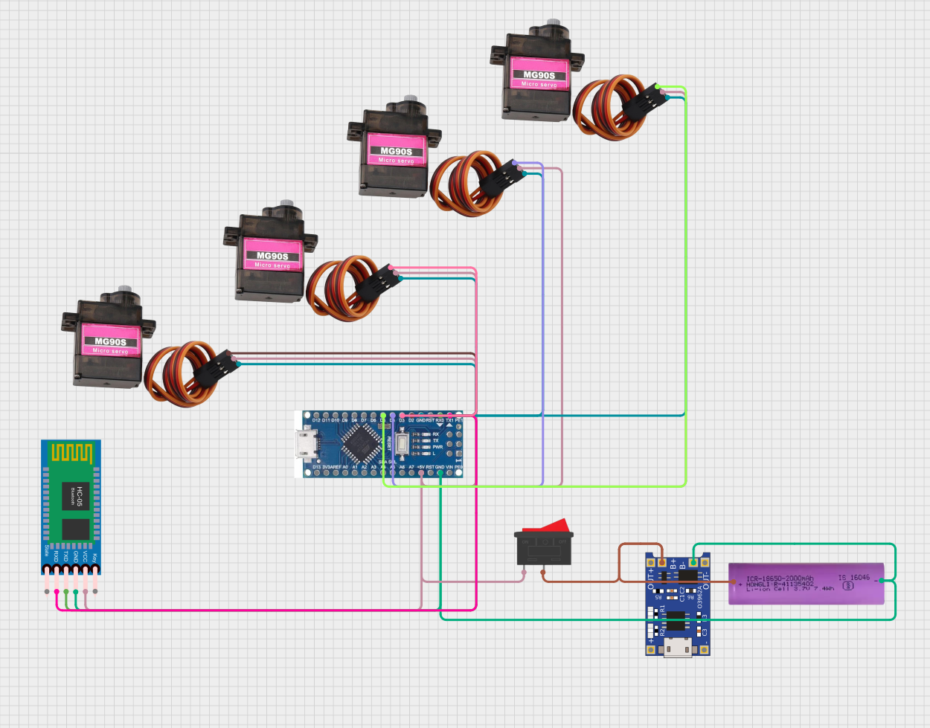

4 SERVO MOTORS ROBOTICS ARM

[CIRCUIT DESIGN]

3.7 VOLT LION BATTERY

CHARGING MODULE

SWITCH

ARDUINO NANO

BLUETOOTH MODULE

SERVO BASE

SERVO SHOULDER

SERVO ELBOW

SERVO GRIPPER